# Comparison - Thiruvanathapuram & Kochi

Introduction

This project is to compare and contrast between the neighborhood characteristics of the two major cities viz, Thiruvananthapuram (Trivandrum) and Kochi (Cochin) of the state of Kerala in India.

Historically Keralites have migrated to the four corners of the world. Due to economic development and rising interconnectedness presently it's no longer necessary for a person to physically relocate another continent or regions for gainful employment. With Covid 19 world over the current trend is to work from home and for many Keralite expartiates reverse migration is very much on the cards.

This study is intended to analyse similarities and differences between the two major cities of Kerala, for expatriates who intend to return and settle back home in Kerala.

Data

Data required are the list of suburbs of both these cities, latitude and longitude of each of these suburbs and foursquare data to corresponding to these coordinates.

The lists of suburbs of both the cities are taken from Wikipedia and their latitude and longitude are downloaded using geocorders.

Details of venues for each suburb is downloaded from foursquare.

Methodology

List of suburbs obtained from Wikipedia was cleaned for availability of location coordinates.

Clustering comparison is used for the suburbs of both cities using Kmeans clustering algorithm to identify differences in characteristics based on venues.

Multiple attempts were done at clustering by varying the number of venues and number of clusters to arrive at the optimal number of clusters.

Folium library is used to plot maps.

Matplotlib is used to plot histograms.

Histograms are used to identify the distinguishing characteristic between the two cities.

## Kmeans

The optimal number of clusters was found to be 3 by varying the number of venues from 1 to 100 and clusters from 2 to 10.

One cluster is found to contain most number of suburbs in each city for all the combinations of venues and clusters tried.

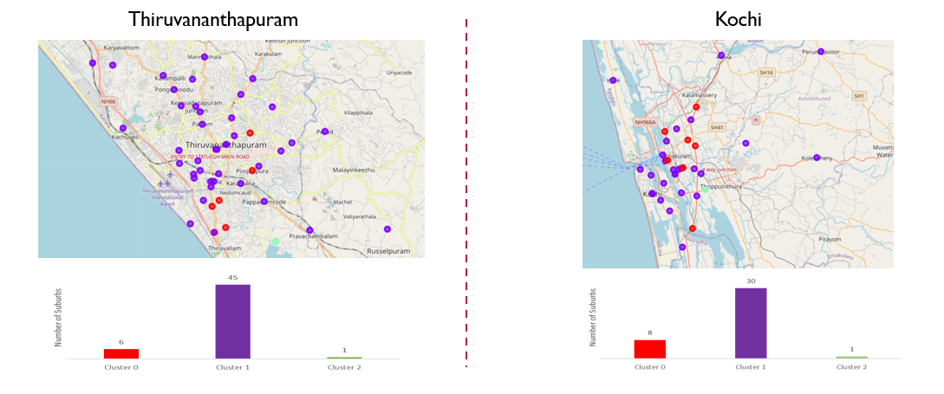

Kmeans finds 3 different types of sububrs in each city.

## Number of Venues

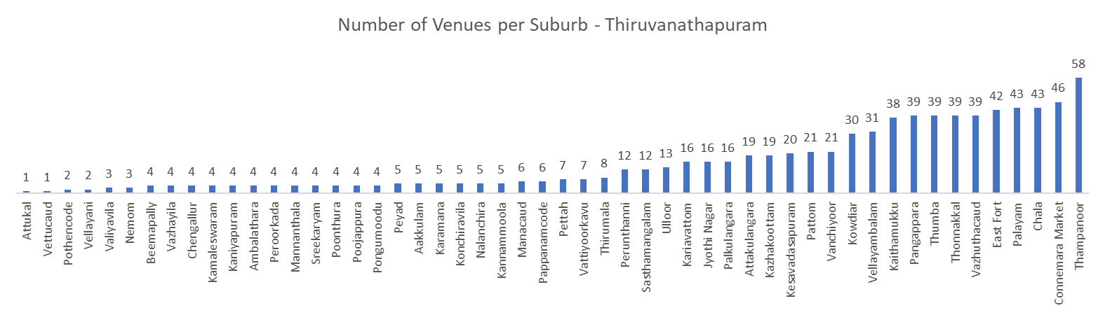

There are 52 suburbs in Thiruvanathapuram

Number of venues range from 1 to 58

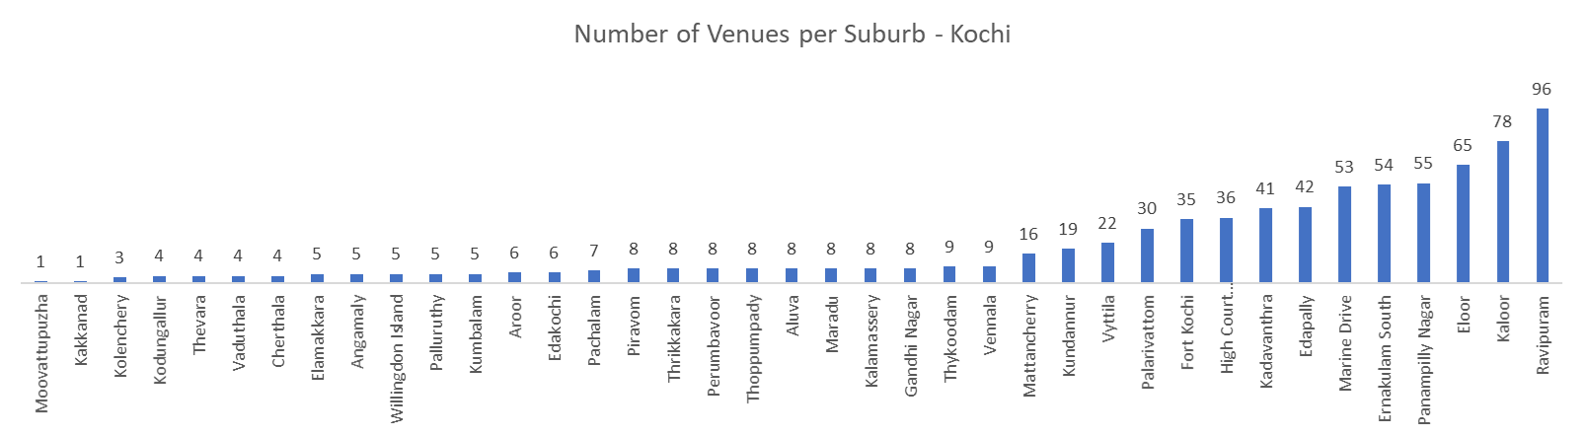

There are 39 suburbs in Kochi

Number of venues range from 1 to 96

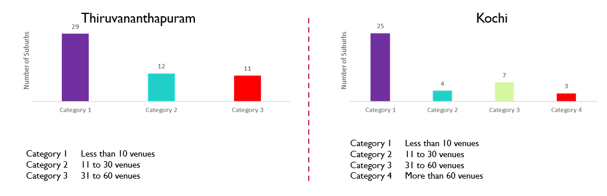

There are a greater number of suburbs in Thiruvananthapuram in Categories 1, 2 & 3.

Category 4 suburbs are there only in Kochi.

Results

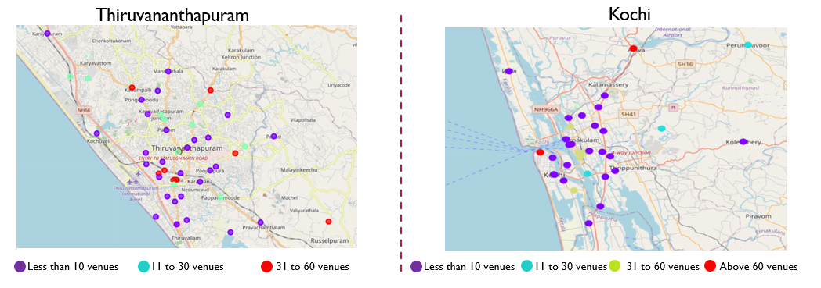

Clustering analysis identifies 3 types of clusters in each city.

Histograms based on number of venues per suburb identifies the following distinguishing characteristics.

Number of suburbs are more in Thiruvanathapuram compared to Kochi.

Density of venues per suburb is higher in Kochi compared to Thiruvanathapuram.

Discussion

Total number of suburbs in Thiruvanathapuram is higher compared to Kochi. Geographically Kochi is on the banks of a lake that causes concentration of venues.

Preliminary result based on number venues indicates Thiruvananthapuram to be more spread out with a relatively lower density of venues per suburbs compared to Kochi.

Conclusion

Preliminary analysis based on foursquare data indicates Thiruvananthapuram to be more spread out with a relatively lower density of venues per suburbs compared to Kochi.

More extensive analysis can be performed comparing the two cities incorporating more dimensions and parameters.